Creative Brief

PRO WRESTLING IN A NEW LIGHT

Mahmoud Abuzeid

Creative Brief – Abuzeid, Mahmoud

 \* What is this project?

Professional wrestling in a new light

\* Who is it for?

Wrestling and non-wrestling fans, basically fans of entertainment

\* Why are we doing it?

To introduce wrestling to everyone

\* What needs to be done?

Create a good responsive website that allows me to portray my message

\* Where and how will it be used?

By people being brought into the pro wrestling world. It’s a global setting that is set to expant and make everyone more knowledgeable about the topic

1. Background Summary: Who is the client? Pro Wrestling

What is the product or service? It’s an informative website for that topic

What are the strengths, weaknesses, opportunities and threats (or SWOTs) involved with this product or service?

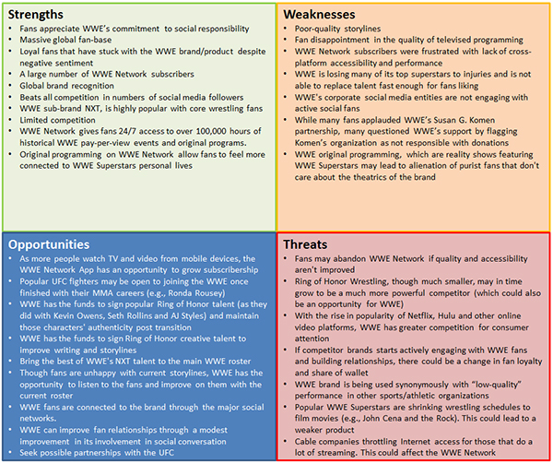

Are there existing research, reports and other documents that help you understand the situation?

Yes, there are so many articles that provide insight about pro wrestling. Here is an example <https://www.wrestlinginc.com/news/>

 2. Overview: What is the project? What are we designing and why? Why do we need this project? What’s the opportunity?

Pro wrestling in a new light, we are designing a website that provides data about this topic to inform the public about wrestling. The opportunity is to create new fans of the product just like a TV show.

3. Drivers: What is our goal for this project? What are we trying to achieve? What is the purpose of our work? What are our top three objectives?

The goal is to be committed to family-friendly content on its television programming, pay-per-view, digital media and publishing channels. Trying to achieve a fair return and benefits to website viewers

We are designing a website that keeps people informed about pro wrestling and its main news, articles, information, and answering questions about the products involved. To entertain, to inform, and finally to empower everyone to watch and learn from pro wrestling, these are the three main objectives of my website.

 4. Audience: Who are we talking to? What do they think of us? Why should they care?

We are taking about wrestling and non-wrestling fans, they mostly are indifferent or think its stupid, because it’s a truly entertaining product that captures the eyes of many with its acrobatics and athleticism. When you think of a typical WWE fan, there's a possibility that a certain picture will come to mind. ... The current audience of WWE by age looks like this – 22 percent is between the ages of 2-17, 23 percent is between the ages of 18-34, 26 percent is between the ages of 35-49 and 30 percent is between the ages of 50 and older.

  5. Competitors: Who is the competition? What are they telling the audience that we should be telling them? SWOT analysis on them? What differentiates us from them?

* Belitor, UFC, and other combat sports are the main competitors.
* Its presented as a sport rather than an entertainment specticale, so being more sports oriented can help

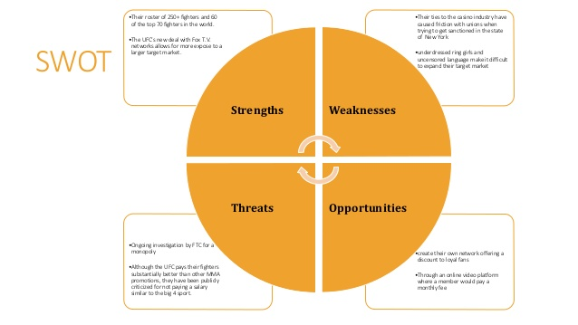

* They are a real sport while we are entertainment.

 6. Tone: How should we be communicating? What adjectives describe the feeling or approach?

The partnership between the agency and the company should be a good creative brief. Sitting down to a face-to-face meeting is helpful, but the act of making a brief on paper solidifies the concepts already discussed and provides a framework for the plan. A brief may be as transparent or as structured as both parties are comfortable with, but the best type of creative brief describes the boundaries within which the Company has full creative competence. The objective is to make the client happy.

7. Message: What are we saying with this piece exactly? Are the words already developed or do we need to develop them? What do we want audiences to take away?

The words are there it’s a matter of organizing the articles and information effectively to better help everyone meet their goals. That this is a good product that everyone should watch as a TV show.

 8. Visuals: Are we developing new images or picking up existing ones? If we are creating them, who/what/where are we photographing or illustrating? And why?

Picking existing one from a library of content, like deviant art, google images, and kupy

9. Details: Any mandatory information that must be included? List of deliverables? Preconceived ideas? Format parameters? Limitations and restrictions? Timeline, schedule, budget?

Depending on your chosen designer, web design costs for a startup company with ambitions on eCommerce can range from a budget-friendly $400 to something closer to $15,000

10. People: Who are we reporting to? Who exactly is approving this work? Who needs to be informed of our progress? By what means?

We are reporting directly to bleacher report as we have their website linked to ours. Most our article ideas are derived from there. We also share the same writers. They will be informed when the website is online and we report to them and the main wresting companies that give us content.